Get Started with Git and Team Services

Last Update: 10/3/2016

Team Services | TFS 2015 | Visual Studio 2015 | [Previous version](https://www.visualstudio.com/en-us/docs/git/get-started-vs2013)

This guide covers the basics so you can get up and running using Git with code already in Team Services. Explore our [full tutorial](https://www.visualstudio.com/en-us/docs/git/tutorial/gitworkflow) for more information on how to use Git from Visual Studio or the command line.

* [Get your code from your Team Services Git repository](https://www.visualstudio.com/en-us/docs/git/gitquickstart#clone)
* [Commit your changes in Git](https://www.visualstudio.com/en-us/docs/git/gitquickstart#commit)
* [Share your changes with others](https://www.visualstudio.com/en-us/docs/git/gitquickstart#push)
* [Sync your changes with others](https://www.visualstudio.com/en-us/docs/git/gitquickstart#pull)

**Get your code**

To get a copy of the source code, you will [clone](https://www.visualstudio.com/en-us/docs/git/tutorial/creatingrepo) a Team Services Git repository. Cloning creates both a copy of the source code for you to work with and all the version control information so Git can manage the source code.

If you don't have a Git repository yet, you can create one [using your own code](https://www.visualstudio.com/en-us/docs/git/tutorial/creatingrepo#init) and then clone the newly created Team Services repository.

* How to clone a repo
* [Command Line](https://www.visualstudio.com/en-us/docs/git/gitquickstart#cmdline0)
* [Visual Studio](https://www.visualstudio.com/en-us/docs/git/gitquickstart#vs0)

Team Services | TFS 2015 | Visual Studio 2015

1. In Team Explorer, open up the Connect page by choosing **Projects and My Teams** then **Manage Connections**

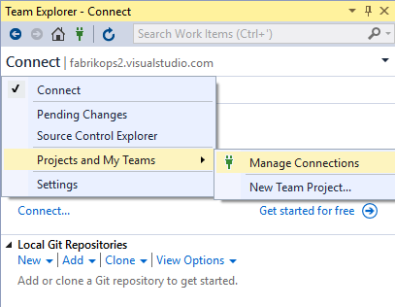

1. Choose **Connect**, select your Team Services account, choose the projects you want to work on, then click **Connect**.
2. Right click on the project and click **Clone...**. Then enter a local folder on your drive to store the downloaded code.

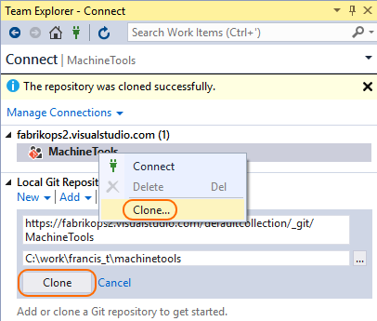

**Commit your work**

Git [branches](https://www.visualstudio.com/en-us/docs/git/tutorial/branches) isolate your changes from other work being done in the project. The recommneded [Git workflow](https://www.visualstudio.com/en-us/docs/git/tutorial/gitworkflow) uses a new branch for every feature or fix you work on. You make [commits](https://www.visualstudio.com/en-us/docs/git/tutorial/commits) in your local Git repository to save your changes on that branch.

* How to commit changes
* [Command Line](https://www.visualstudio.com/en-us/docs/git/gitquickstart#cmdline1)
* [Visual Studio](https://www.visualstudio.com/en-us/docs/git/gitquickstart#vs1)

Visual Studio 2015

1. 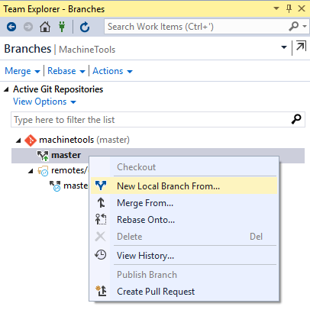In Team Explorer, click the drop down and choose **Branches**. Right click the master branch and choose **New Local Branch From...**  
     
   Choose a descriptive branch name for your work to remind you and others what kind of work is in the branch.
2. Make changes to the project. Git will keep track of changes made to the code both inside and outside of Visual Studio.
3. When you are satisfied with the changes, save them in Git using a commit. Open up the **Changes** view from Team Explorer. Verify the included changes, add a message describing the changes, and click **Commit**.

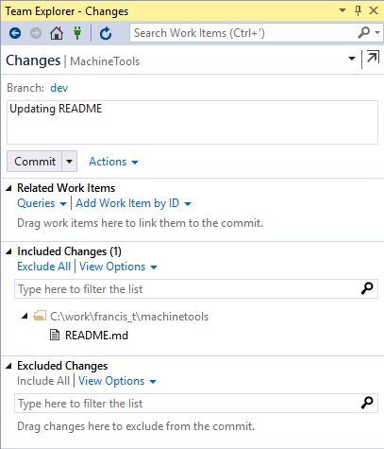

**Share your changes**

When you are ready to share your changes with the team, you [push](https://www.visualstudio.com/en-us/docs/git/tutorial/pushing) those changes so that others can reach them. You can only push changes after you add commits to a branch.

Once you push the changes, you can create a [pull request](https://www.visualstudio.com/en-us/docs/git/tutorial/pullrequest) to let others know you'd like to have the changes reviewed and added to the master branch of the code.

* How to share your code
* [Command Line](https://www.visualstudio.com/en-us/docs/git/gitquickstart#cmdline2)
* [Visual Studio](https://www.visualstudio.com/en-us/docs/git/gitquickstart#vs2)

Visual Studio 2015

1. 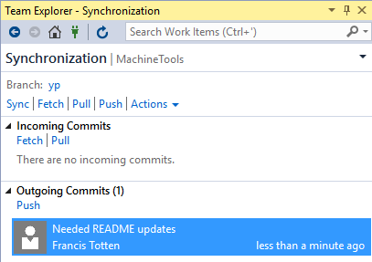Open up the **Synchronization** view in Team Explorer. You can see the outgoing commits and share them by clicking **Push** if you are working with a branch that is already shared, or **Publish** if you are working with a newly created local branch.
2. Create a pull request so that others can review your changes. Open **Pull Requests** in Team Explorer, and click**New Pull Request**. Verify the remote branch to merge the changes into, such as my-feature.

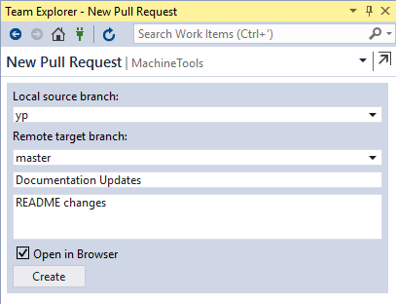

1. You can review comments made in your [pull request](https://www.visualstudio.com/en-us/docs/git/tutorial/pullrequest) in a web browser on the Visual Studio Team Services project page. Once all changes are approved by the team, you complete the pull request through the web browser.

**Sync with others**

To get changes from others and keep your code up to date, you [pull](https://www.visualstudio.com/en-us/docs/git/tutorial/pulling) commits made by others and merge them into your branch. Git is very good about merging multiple changes even in the same file, but sometimes you might have to [resolve a merge conflict](https://www.visualstudio.com/en-us/docs/git/tutorial/merging). It's a good idea to pull your branches regularly to keep them up to date with the changes from others. This makes sure that your feature branches from your main branch are using the latest version of the code.

* How to sync with others
* [Command Line](https://www.visualstudio.com/en-us/docs/git/gitquickstart#cmdline3)
* [Visual Studio](https://www.visualstudio.com/en-us/docs/git/gitquickstart#vs3)

Visual Studio 2015

1. Open up the **Sync** view in Team Explorer. You can download the latest changes to the branch you are on using the "Pull" link.

